Add Client Key and Agent Key to Air and Ocean Client Pricing
Login to WEBEX

Client Key Entry – enter in one database and it updates for all
Open AIR CLIENT PRICING
Run MARGINS FOR IDS COMMISSION REPORT VIEW for current month (e.g. if August run from AUGUST 4 thru SEPTEMBER 3 - see notes to change the dates in the view) to find any with no client key entered with the name. If it is entered it should be entered in the format Cross – 1*CROSS.2 substituting client name and key. The key is found in the IDS CM.MAINT program. See next step.
This is good time to fix/enter all margins as well.
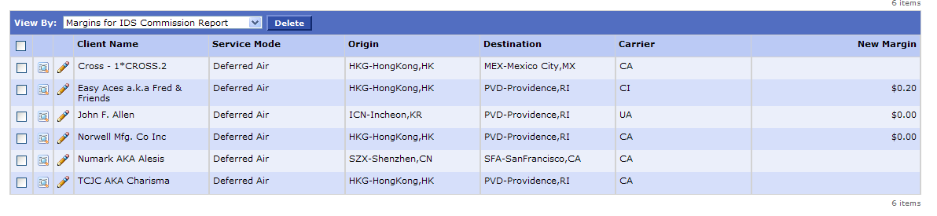

IDS CM.MAINT lookup
Look up client key in the IDS system. 14. IDS SYSTEM, 1. IMPORT, 1. BREAK BULK, 13. FILE MAINTENANCE MENU, 1. BROKER MAINTENANCE/BILL TO PARTY. Type name of client and choose the appropriate key to enter.
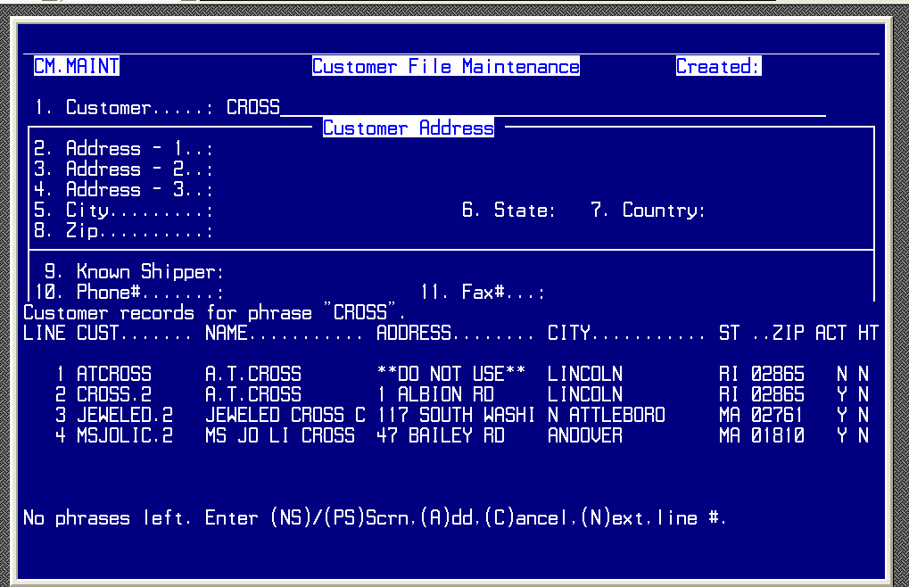
Edit the WEBEX record and add … – 1*clientkey.
Continue until all have been entered.

Change dates in the view to run margin report

Click Views – MARGINS FOR IDS COMMISSION REPORT
Scroll down to Filtering – change dates (always the 4th of the prior month thru the 3rd of the current month)
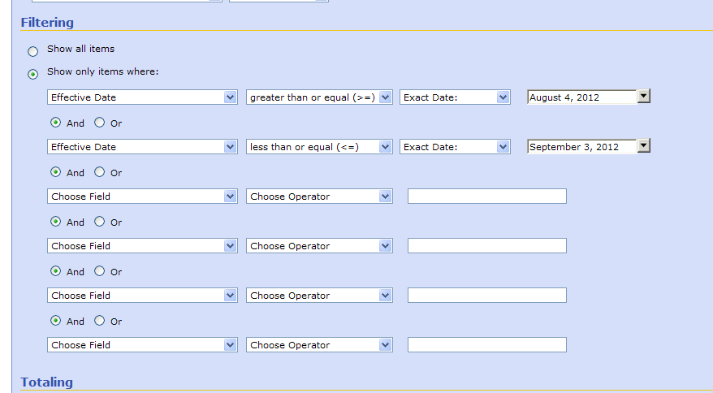
Save

Ocean – Origin Partner Entry
